Fig 4.1 shows the heart of a mammal. Examine it carefully and answer the following questions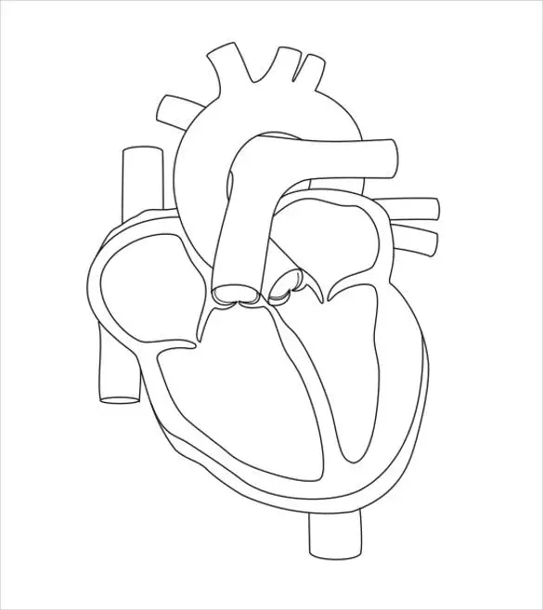



1. State the name of X. [1]
2. Explain why mammals are said to have double circulation. [2]
3. (i) What is the function of the median septum in Fig 4.1? [1]

(ii) What health problems will a person with a hole in the median septum face? [1]